Social Media: Suggestions for Weekly Posts on Facebook and Twitter
The social media posts below should be accompanied with photos or graphics to attract attention and make the posts more interesting. Feel free to use photos of your congregation or your church events. On the last few pages of this document, there are Covered California graphics, videos and photos you may use from Covered California events.

Covered California Sign-Up Period: Oct. 15, 2018 – Jan. 15, 2019
Twitter Posts | Facebook Posts
Covered California’s new sign-up period lasts 90 days from Oct. 15-Jan.15. Sign up for health insurance TODAY. Visit CoveredCA.com #CoveredCA | OPEN ENROLLMENT FOR COVERED CALIFORNIA HAS BEGUN!  Covered California’s sign-up period remains 90 days – the same as years before – and runs from Oct. 15, 2018 until Jan. 15, 2019. We want all members of our community to be in good health, so we encourage everyone to get health insurance. Through Covered California, many people can obtain affordable coverage from a quality health insurance company, and may also qualify for financial help to assist paying your monthly health care costs. Visit CoveredCA.com or call (800) 300-1506 for more information and to get free in-person, confidential help with enrolling. Sign up by Dec 15 to have your health coverage start Jan. 1.
Life can change in an instant if you fall and break your leg. Make sure you have a health plan that covers medical costs when life takes unexpected turns. Sign up at CoveredCA.com #CoveredCA | LIFE CAN CHANGE IN AN INSTANT!  We all know that “life can change in an instant,” as events of the past few years have shown us. But in terms of health care, what happens if you break your leg or your child falls and needs stitches – if you DON’T have health insurance? Fact is it will cost you thousands of dollars in medical expenses, and may put you and your family in financial debt. Covered California’s marketing theme is “Life can change in and instant,” to remind us why it’s so important for everyone to make sure they are enrolled into health insurance plans to cover these medical costs when it’s needed. Visit CoveredCA.com or call (800) 300-1506 for more information and to get free in-person, confidential help with enrolling. Sign-up period ends Jan.15, 2019. Sign up by Dec. 15 to have your coverage start Jan. 1.
You deserve good health. Get health insurance for you and your family at an affordable price. CoveredCA.com CoveredCA | YOU DESERVE GOOD HEALTH.  Covered California offers everyone the security of having health insurance — even those who have been denied insurance because of a medical condition. Covered California offers affordable health care plans from brand-name health insurance companies. Visit CoveredCA.com to shop and compare plans and enroll in coverage, or find free in-person and confidential assistance near you. Everything important should be insured, including your health. Don’t delay, sign up today.
FACT: You can’t be denied health insurance, even with a pre-existing medical condition. Sign up today on CoveredCA.com #CoveredCA |  | GET THE FACTS ABOUT HEALTH CARE COSTS.  Did you know that getting health insurance is at your fingertips? Or that you can get financial assistance to help pay for that insurance? You can also get free in-person, confidential assistance to help you find the right plan for you and your budget. Go online to CoveredCA.com or call (800) 300-1506 to get more information or to find someone near you who can help you sign up.
Help your loved ones get insurance from a brand-name company. Have them visit CoveredCA.com to get covered. #CoveredCA |  | GIVE THE GIFT OF HEALTH.  Do you know someone in your family or your community who needs health insurance but is worried it might be too expensive? Covered California offers financial help to assist you with paying your monthly health care costs, and everyone can have quality health coverage from leading insurance companies at an affordable cost. Help them sign up today! To find out more about available financial help or to find a nearby Certified Enrollment Agent to get free in-person, confidential assistance, visit CoveredCA.com or call (800) 300-1506.
Live the ABUNDANT LIFE. Get health coverage for yourself and your family. Go to CoveredCA.com #CoveredCA |  | LIVE THE ABUNDANT LIFE.  Being healthy means more than just not being sick. Good health is life lived at your full potential — physically, mentally, socially and spiritually. Each and every one of us is entitled to live that abundant life, but many in our community can’t because they lack the health insurance they need and deserve to get healthy and live in good health. Covered California has health plans to meet everyone’s needs and budget. You can enroll on CoveredCA.com or by calling (800) 300-1506. New sign-up and renewals end Jan. 15. Sign up by Dec. 15 to have coverage starting Jan. 1.

Additional Posts During Sign-Up Period: Oct. 15, 2018 – Jan. 15, 2019

Twitter Posts | Facebook Posts
Don’t wait until it’s too late. Learn about your various #CoveredCA health care options. Visit CoveredCA.com | DON’T WAIT TO GET HEALTH INSURANCE.  California has recorded some of the nation’s most dramatic gains in health coverage since 2014 while building a competitive insurance marketplace that offers consumers enhanced protections from high medical bills. Find out what that means for you and your loved ones. #CoveredCA offers a variety of free support to help you learn about your health care options online, by phone, at community events and at more than 800 Covered California storefronts statewide. Don’t wait until it’s too late. Visit CoveredCA.com today.
There are #CoveredCA enrollment centers in our community to help you get covered. Find one near you: http://bit.ly/290ldZa | BEING COVERED IS THE BEST PLAN.  Obtaining health coverage is one of the most important things you can do to protect yourself and your family. Being covered is the best plan for getting and staying healthy. There are #CoveredCA enrollment centers in our community to make it easier to shop for coverage. Find one near you: http://bit.ly/290ldZa
High-quality, brand-name health insurance is available at a low cost or no cost. Check out #CoveredCA http://bit.ly/291OLUI. | NAME-BRAND HEALTH INSURANCE IS AVAILABLE TO YOU.  Don’t put your health or your family’s health at risk! Get health and dental insurance. Financial help is available to help you get high-quality, brand-name health insurance at a lower cost, and in some cases at no cost. Shop and compare Covered California plans today http://bit.ly/2dCoQWR.
You know you need to get health coverage! The #CoveredCA team of experts can help find the best plan for you http://bit.ly/291OLUI. | GET HEALTH INSURANCE FOR YOU AND YOUR FAMILY.  You know that you need to get health coverage. Don’t know where to start? Covered California has a team of experts assisting families right here in our community. Schedule an appointment with us today for free help and find the best plan to give you and your family the protection you need for whatever health issues may come your way. CoveredCA. Visit http://bit.ly/291OLUI.
Last Week of Sign-Up Period: Jan. 8-15, 2019
Twitter Posts | Facebook Posts
Please post Jan. 8-13:  It’s the LAST WEEK to enroll in a health care plan. The deadline is Jan. 15. Get enrolled at CoveredCA.com CoveredCA | Please post Jan. 8-13:  IT’S THE LAST WEEK TO SIGN UP FOR A HEALTH PLAN THROUGH COVERED CALIFORNIA.  Sign up ends on Jan. 15. We urge all who still have not signed up for health coverage to do so before the Jan. 15 deadline. Through Covered California, you can get health insurance with a quality health insurance company that provides free preventive care services, like regular checks-ups and prescriptions. Sign up today on CoveredCA.com or call (800) 300-1506 to find free in-person, confidential help to sign up..
Please post on Jan. 14:  Only 2 days left! DON’T FORGET to sign up for a health insurance plan! The last day of the sign-up period is Jan. 15.CoveredCA.com CoveredCA | Please post on Jan. 14:  ONLY TWO DAYS LEFT TO SIGN UP FOR A HEALTH PLAN THROUGH COVERED CALIFORNIA.  Financial assistance is available to help you pay for your monthly health plan premiums through Covered California, the state’s health insurance program. Don’t leave your money on the table! Enroll today to get the health coverage you need and deserve. Go online to CoveredCA.com to shop and compare health plans and find the right one for you, your family and your budget. Or call (800) 300-1506 to get free in-person, confidential assistance from a Certified Enrollment Counselor or Certified Insurance Agent near you. Open enrollment ends on Tues., Jan. 15.
Please post on Jan. 15:  Today is the LAST DAY! Covered California’s sign-up period ends today, Jan. 15. Visit CoveredCA.com #CoveredCA and sign up today! | Please post on Jan. 15:  SIGN-UP PERIOD ENDS TODAY! SIGN UP NOW FOR COVERED CALIFORNIA!  You have until midnight tonight, Jan. 15, to sign up for a health plan through Covered California. Go online to CoveredCA.com to shop and compare and find the right health plan for you, your family and your budget. Remember that financial help is available to assist you in paying your monthly health care costs. Brothers and sisters, don’t go without the peace of mind that comes with knowing you and your family are covered should you need it. You can also call (800) 300-1506 to get help to sign up.
Special Enrollment
Special enrollment is available throughout the year. Therefore, Facebook and Twitter posts can go out at any time. We recommend two to three posts per month from February 2019 to October 2019.
Twitter Posts | Facebook Posts
Just got married or had a baby? Make sure your family has health coverage to keep them healthy & strong. CoveredCA.com #CoveredCA | BLESSED WITH A NEW BABY?  If you’ve recently been blessed with the birth of a child, you know the many joys that come with parenthood. You also know the many responsibilities, like making sure that your child is healthy and well. With Covered California, you can get health coverage for your new baby up to 60 days after he or she is born and there is financial assistance to help you pay for the monthly premiums. Go online to CoveredCA.com to shop and compare plans and find out which health plan fits your family’s budget. You can also call (800) 300-1506 to find free in-person, confidential enrollment assistance near you. #CoveredCA
If you lost your health insurance, you can enroll in Covered California to get quality health coverage. CoveredCA.com #CoveredCA | CONGRATULATIONS, NEWLYWEDS!  We extend our heartfelt congratulations to those in our congregation and extended family who have recently been joined in marriage. It is a blessed event that we joyfully celebrate along with the happy couples. We remind those newlyweds that if you don’t have health insurance, you can obtain health coverage through Covered California up to 60 days after your wedding date. Go online to CoveredCA.com to shop and compare for plans, or call (800) 300-1506 to get free in-person, confidential assistance near you. #CoveredCA
Lost your job & your health insurance? No worries, enroll in a health plan with Covered California. CoveredCA.com #CoveredCA | TO EVERY THING THERE IS A SEASON…  We experience many changes in our lives and the lives of our loved ones — birth, death, marriage, divorce, starting a job and losing a job. These life changes usually impact other areas of our lives — like access to quality health insurance. If you’ve recently experienced any of these life events, you have the opportunity to get health coverage through Covered California. Go online to CoveredCA.com or call (800) 300-1506 to find out about health plan  options that fit you and your budget. You have up to 60 days after the life event to enroll. #CoveredCA
New to California? Enroll in a health insurance plan & get quality health coverage for New to California? Enroll in a health insurance plan & get quality health coverage for you & your family. CoveredCA.com #CoveredCA | NEW TO CALIFORNIA?  One of the first things you need to take care of is making sure you have coverage to protect your health. With health insurance, you can have peace of mind knowing that when you need to see a doctor, have a medical test or go to the hospital, it will be covered. With Covered California, you can get quality health insurance at an affordable cost. Enroll today on CoveredCA.com or call (800) 300-1506 to find free, in-person confidential help to get you enrolled. #CoveredCA
If you’re 26, you can get your own health insurance with your own doctor. Sign up today. CoveredCA.com #CoveredCA | DID YOU RECENTLY TURN 26?  You have the opportunity to get your own health plan through Covered California. Go online to CoveredCA.com or call (800) 300-1506 to find out about health plan options that fit your needs and your budget. It’s worth it and you’re worth it. #CoveredCA
Covered California Graphics, Videos & Photos for
Twitter and Facebook Posts
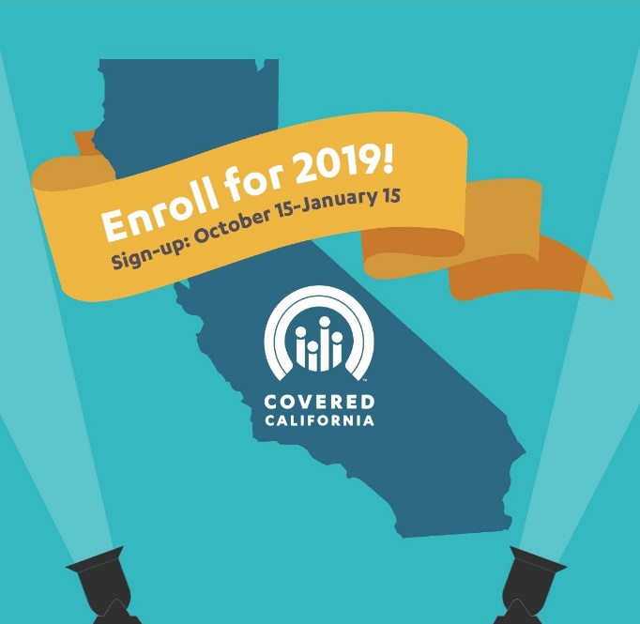
VIDEOS
VIDEO: Real Stories from Covered California - Anita, San Pablo, CA
VIDEO: Real Stories from Covered California –Anassa’s Story, San Francisco, CA:

