Table of Contents
New Compliance Site Visit 2
Compliance Site Visit With No Findings 2
Compliance Site Visit With Findings 3
Corrective Action Plan 4
Findings 5

New Compliance Site Visit
Compliance Site Visits are scheduled and conducted to verify the compliance of a location for a fiscal year. When a new Compliance Site Visit is generated, the Entity will receive 30-day notice via email prior to the onsite visit.
Subject: Compliance Site Visit Scheduled [Entity Name]
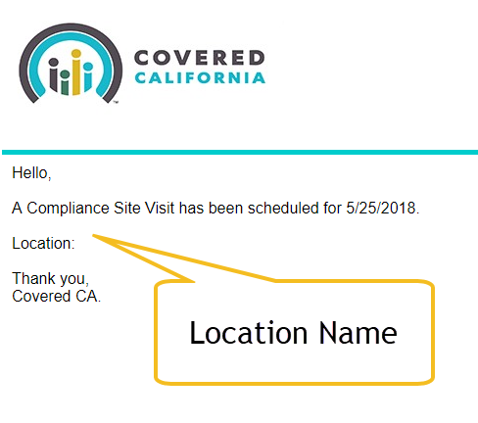
Body:

Compliance Site Visit With No Findings
Once the visit occurs and it is documented, if there are no findings, the Entity will receive an email confirming the compliance in all the areas that were observed.
Subject: Compliance Site Visit completed with no findings: [Entity Name]
Attachment: Full sheet of responses.
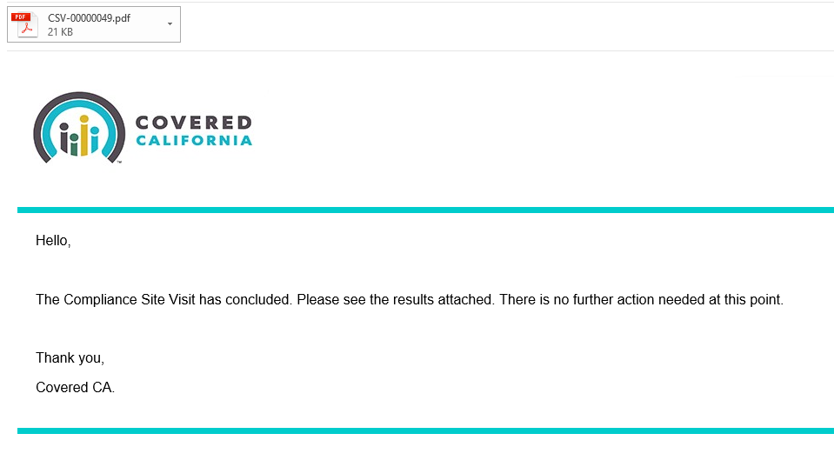
Body:

Compliance Site Visit With Findings
Once the visit occurs and it is documented, if there are some findings, the Entity will receive an email confirming the non-compliance in those areas that were observed. This email contains a link to a Corrective Action Plan in the portal.
Subject: Compliance Site Visit Concluded: [Entity Name]
Attachment: Findings highlights and full sheet of responses.
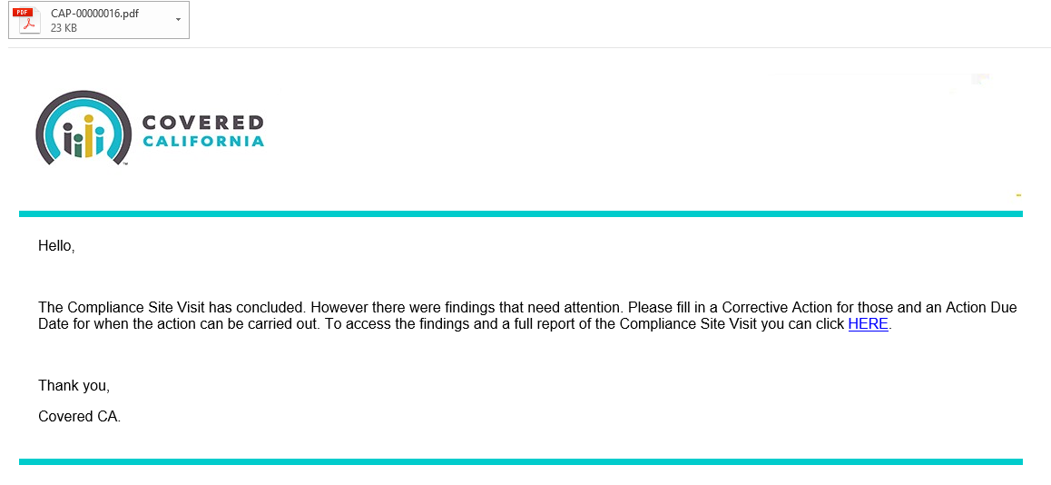
Body:

Corrective Action Plan
The link takes the user directly to the Detail of the Corrective Action Plan. The entity is responsible to include a proposed action per individual finding and mark each finding complete when the corrective action has been taken.
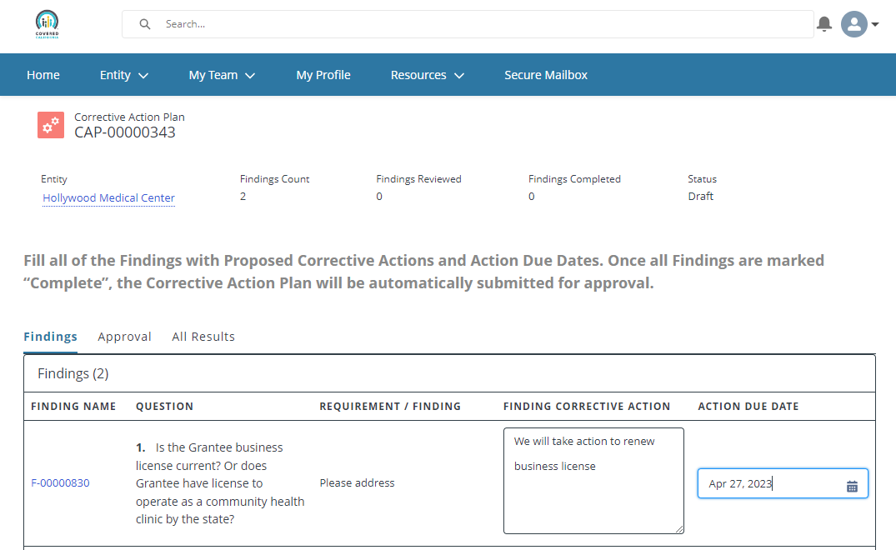
Proposed actions
Due date
Additionally, this screen has a Tab that contains Approval History and a Full list of responses for the visit (same as the pdf in the initial email). It serves as a reference if needed.
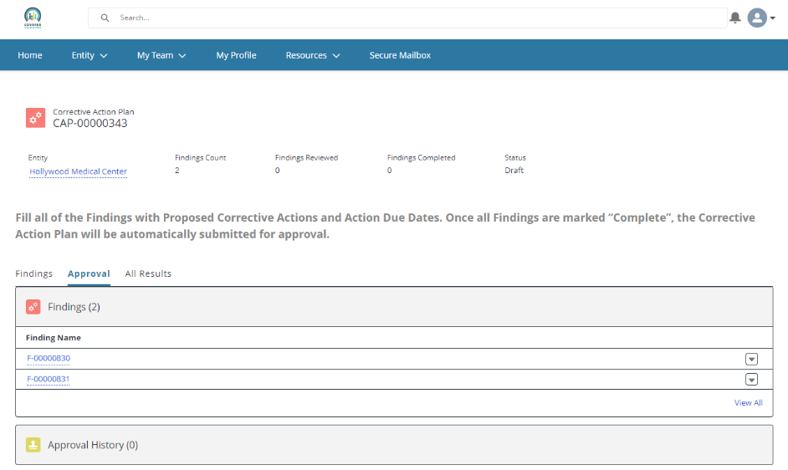

Findings
To access the related Findings and mark them as complete click on each Finding name within the table. At this point the CAP is “Draft”.

Inside the Finding page you have a button to “Mark Complete”.
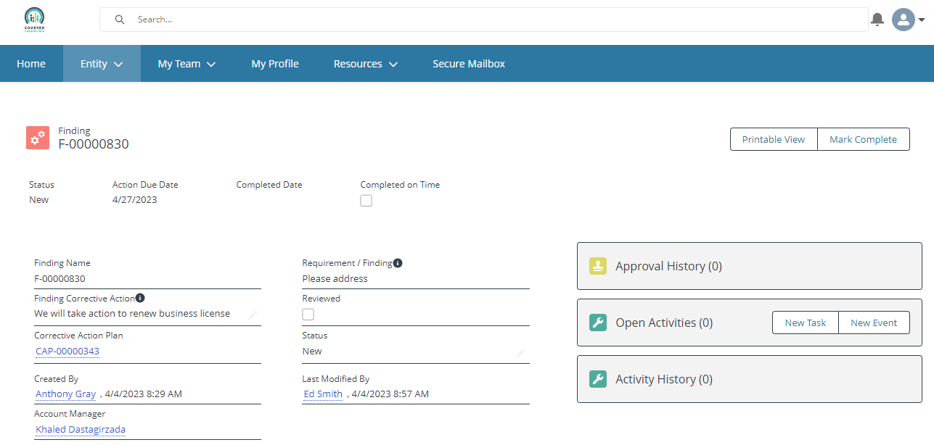
This brings up a window for comments on the submission. Click Next.
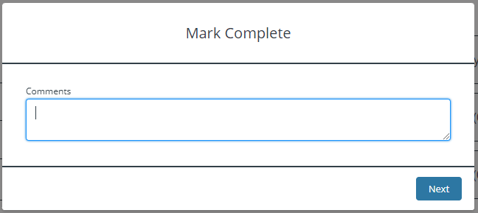

Once all findings are marked “Complete”, the Corrective Action Plan will be automatically submitted for final approval. The Status during this last step is “In Review”.
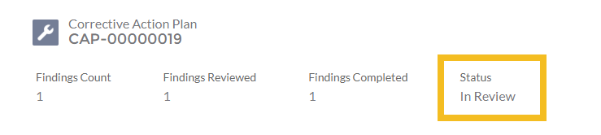

The conclusion of this review step will conclude the process and will finalize the CAP.
Subject: Corrective Action Plan closing was approved: [Entity Name]
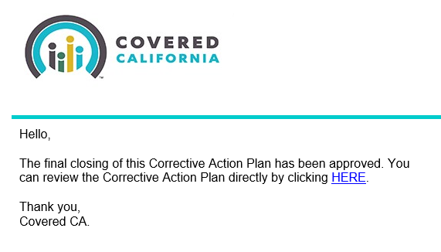
Body:

When reviewing the Corrective Action Plan at this point it is “Closed”

