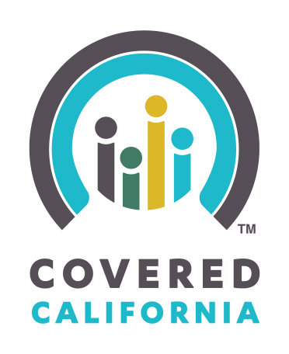
Brief for Newsletters or Handouts
to Reach Patients and Families
Open Enrollment Is Here Again — Covered California Is the Place Where Consumers Can Get Financial Help to Pay for Health Insurance
Covered California’s open enrollment begins Nov. 1, 2015 and runs through Jan. 31, 2016. If you, your family members or friends need health insurance, this is the time for them to sign up. Covered California offers financial assistance that can help reduce health care costs. Having health insurance brings peace of mind and you can be covered for all of 2016 if you sign up by Dec. 15.

Covered California is the only place where an individual can get financial assistance with their health insurance. Last year, nine out of 10 enrollees qualified for some level of financial help and more than 120,000 enrollees paid less than $10 per month per individual. Covered California offers a range of plans so that consumers can choose the health plan and level of coverage that best meets their needs and budget.

In addition, many Californians could qualify for Medi-Cal, which is free or low-cost health coverage for low-income Californians. Medi-Cal is health coverage, just like the coverage from Covered California health plans and if you qualify for Medi-Cal, your health care will be free or at a lower cost to you and your family. A single application on CoveredCA.com will let you know if you qualify for Covered California or Medi-Cal coverage.

Health insurance can be complicated. If you, your family members or friends need health coverage, they can get free, confidential assistance from one of the more than 28,000 individuals in California who are ready to help them enroll. You can begin by finding confidential in-person help from a Certified Insurance Agent, Certified Enrollment Counselor or a county eligibility worker at http://www.coveredca.com/get-help/local/. You can also sign up by telephone (800) 300-1506 or visit CoveredCA.com to apply online.

